Project Design Phase-II
Data Flow Diagram & User Stories
Date | 18 JUNE 2026
Team ID | Vishal Gudla
Project Name | ShopEZ — E-commerce Application
Maximum Marks | 4 Marks
Data Flow Diagrams:
A Data Flow Diagram (DFD) is a traditional visual representation of the information flows within a system. A neat and clear DFD can depict the right amount of the system requirement graphically. It shows how data enters and leaves the system, what changes the information, and where data is stored.
ShopEZ DFD Overview:
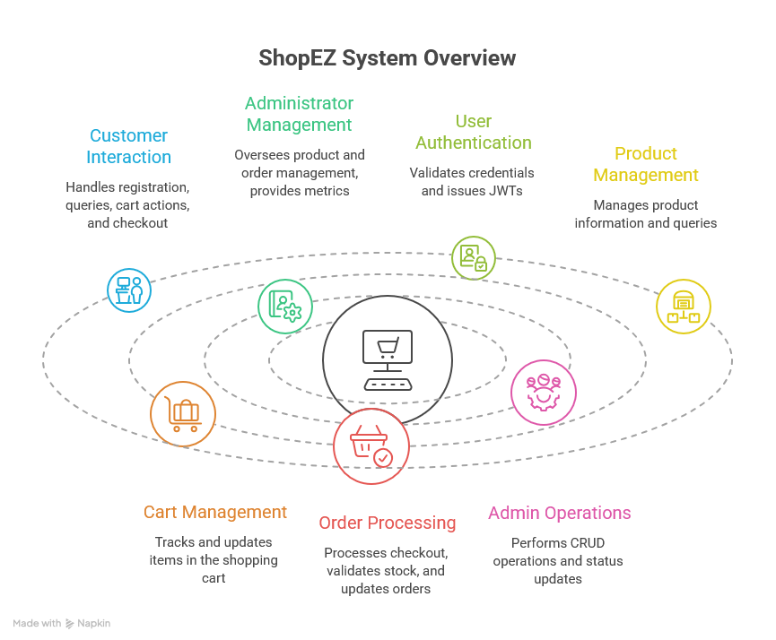
User Stories
The following user stories define the expected functionality of ShopEZ from the perspective of each user type. Each story is mapped to a functional epic with acceptance criteria, priority, and sprint release.
User Type | Functional Requirement (Epic) | USN | User Story / Task | Acceptance Criteria | Priority | Release
Customer (Web/Mobile User) | User Registration | USN-1 | As a customer, I can register on ShopEZ by providing my full name, email, password, and 10-digit Indian mobile number. | I can log in and access my profile and shopping cart | High | Sprint-1
 |  | USN-2 | As a customer, I want to receive an error if I try to register with an email that is already in use. | System shows a clear validation error and prevents duplicate accounts | High | Sprint-1
 |  | USN-3 | As a customer, I want my password to be securely stored so that my account remains safe. | Password is hashed via bcryptjs; plaintext never stored | High | Sprint-1
 | User Login | USN-4 | As a customer, I can log into ShopEZ using my registered email and password. | A JWT token is issued and I am redirected to the home page | High | Sprint-1
 |  | USN-5 | As a customer, I want to be automatically redirected to the login page when I try to access a protected route without logging in. | Unauthenticated access returns 401 and redirects to /login | High | Sprint-1
 | Product Catalog | USN-6 | As a customer, I can browse all available products on the Products page with prices displayed in ₹. | All active products are listed with correct INR pricing | High | Sprint-1
 |  | USN-7 | As a customer, I can search for products by keyword so that I can quickly find what I am looking for. | Search results update to match the entered keyword | High | Sprint-1
 |  | USN-8 | As a customer, I can filter products by category so that I can narrow down my browsing. | Products are filtered to show only the selected category | Medium | Sprint-1
 |  | USN-9 | As a customer, I can click on a product to view its full details including description, price in ₹, and stock availability. | Product detail page loads with all relevant information | High | Sprint-1
 | Shopping Cart | USN-10 | As a customer, I can add a product to my cart so that I can purchase it later. | Item appears in my cart; cart count updates in the navbar | High | Sprint-1
 |  | USN-11 | As a customer, I can update the quantity of an item in my cart. | Cart total recalculates correctly after quantity change | High | Sprint-1
 |  | USN-12 | As a customer, I can remove an item from my cart. | Item is removed and cart total updates accordingly | High | Sprint-1
 |  | USN-13 | As a customer, my cart persists across sessions and devices since it is stored in MongoDB. | Cart contents are the same when I log in from another device | Medium | Sprint-2
 | Checkout | USN-14 | As a customer, I can enter my shipping address, 10-digit phone number, and 6-digit pincode to place an order. | Form validates Indian phone and pincode formats before submission | High | Sprint-1
 |  | USN-15 | As a customer, I can see the shipping fee calculated automatically (free above ₹500, flat ₹50 below). | Correct shipping fee is displayed and included in the total | High | Sprint-1
 |  | USN-16 | As a customer, I can place an order using Cash on Delivery (COD). | Order is created with status 'pending'; stock is decremented; cart is cleared | High | Sprint-1
 |  | USN-17 | As a customer, I am prevented from placing an order if the product is out of stock. | System shows a stock validation error and blocks the order | High | Sprint-1
 | Order Tracking | USN-18 | As a customer, I can view my full order history from my profile page. | All past orders are listed with their current status | High | Sprint-2
 |  | USN-19 | As a customer, I can view the details of a specific order including items, total, and current status. | Order detail page loads with correct information | Medium | Sprint-2
 | User Profile | USN-20 | As a customer, I can view my profile details (name, email, phone). | Profile page displays my correct registered information | Medium | Sprint-2
 |  | USN-21 | As a customer, I can update my profile information. | Changes are saved and reflected immediately on the profile page | Medium | Sprint-2
Administrator | Admin Dashboard | USN-22 | As an admin, I can view a dashboard showing total users, products, orders, and cumulative revenue. | Dashboard displays correct aggregate metrics | High | Sprint-2
 |  | USN-23 | As an admin, I can see the 5 most recent orders on the dashboard for quick review. | 5 latest orders are listed with order ID, amount, and status | High | Sprint-2
 | Product Management | USN-24 | As an admin, I can add a new product with name, description, price (₹), category, stock quantity, and image URL. | New product appears in the catalog and is browsable by customers | High | Sprint-2
 |  | USN-25 | As an admin, I can edit the details of an existing product. | Updated product details are immediately reflected in the catalog | High | Sprint-2
 |  | USN-26 | As an admin, I can delete a product from the catalog. | Product is removed and no longer visible to customers | High | Sprint-2
 |  | USN-27 | As an admin, I can toggle a product's active/inactive status to control its visibility. | Inactive products are hidden from the customer catalog | Medium | Sprint-3
 | Order Management | USN-28 | As an admin, I can view all customer orders across the platform. | Full order list is displayed with customer details and status | High | Sprint-2
 |  | USN-29 | As an admin, I can update the status of an order through the pipeline (pending → confirmed → packed → shipped → delivered → cancelled). | Status change is saved and reflected in the customer's order tracking view | High | Sprint-2
 | User Management | USN-30 | As an admin, I can view a list of all registered users on the platform. | All users are listed with their name, email, and role | Medium | Sprint-3

